

Memo
To: Professor Pisano
From: Team 9
Team: 9
Date: 11/18/2021
Subject: Test Plan
- List of Materials
Hardware:
Raspberry Pi 4 B (with 32GB SanDisk SDHC Class 10 card)
Raspberry Pi fans
BerryGPS-IMUv4 (Part number: 8542129523)
Raspberry Pi 4 Camera IR ()
QWIIC Connector and Cable for Raspberry Pi
15W Power Adapter (Pi4)
Mini HDMI to HDMI cable
Active GPS antenna
Software:
C language:
Data collection, from IMU to readable .txt file
Python Script:
GPS receiver, from GPS to .txt file
Recording video in h.264 format
Image Analysis to capture the change of Airspeed dial
XDR File:
The input file to the Xplane simulator.

asdfasdf
Include part numbers

2.0 Equipment Setup

The equipment and setups are divided into three parts: Raspberry Pi with BerryGPS-IMU and Camera; the corresponding software to process the data and to analyze image. Raspberry Pi as the data processing unit. The camera unit connect to MIPI CSI camera port on Raspberry Pi; connect the BerryGPS-IMU with Qwiic connector to the left end of Raspberry Pi, the IMU use 3.3V as power supply, and SDA and SCL pin to communicate. To get a stable GPS single, the active GPS antenna is connected on the IMU. Inside the Raspberry Pi, the IMU_interface.c will capture the IMU data(pitch, roll, yaw) and translate them into the IMU_data.txt; the GPS.py transfer the data to the GPS_data.txt; the Camera_test.py capture the video and save them in the Raspberry Pi; the Pressure_Sensor.py transfer the data of temperature, pressure, and altitude to the Pressure_data.txt.

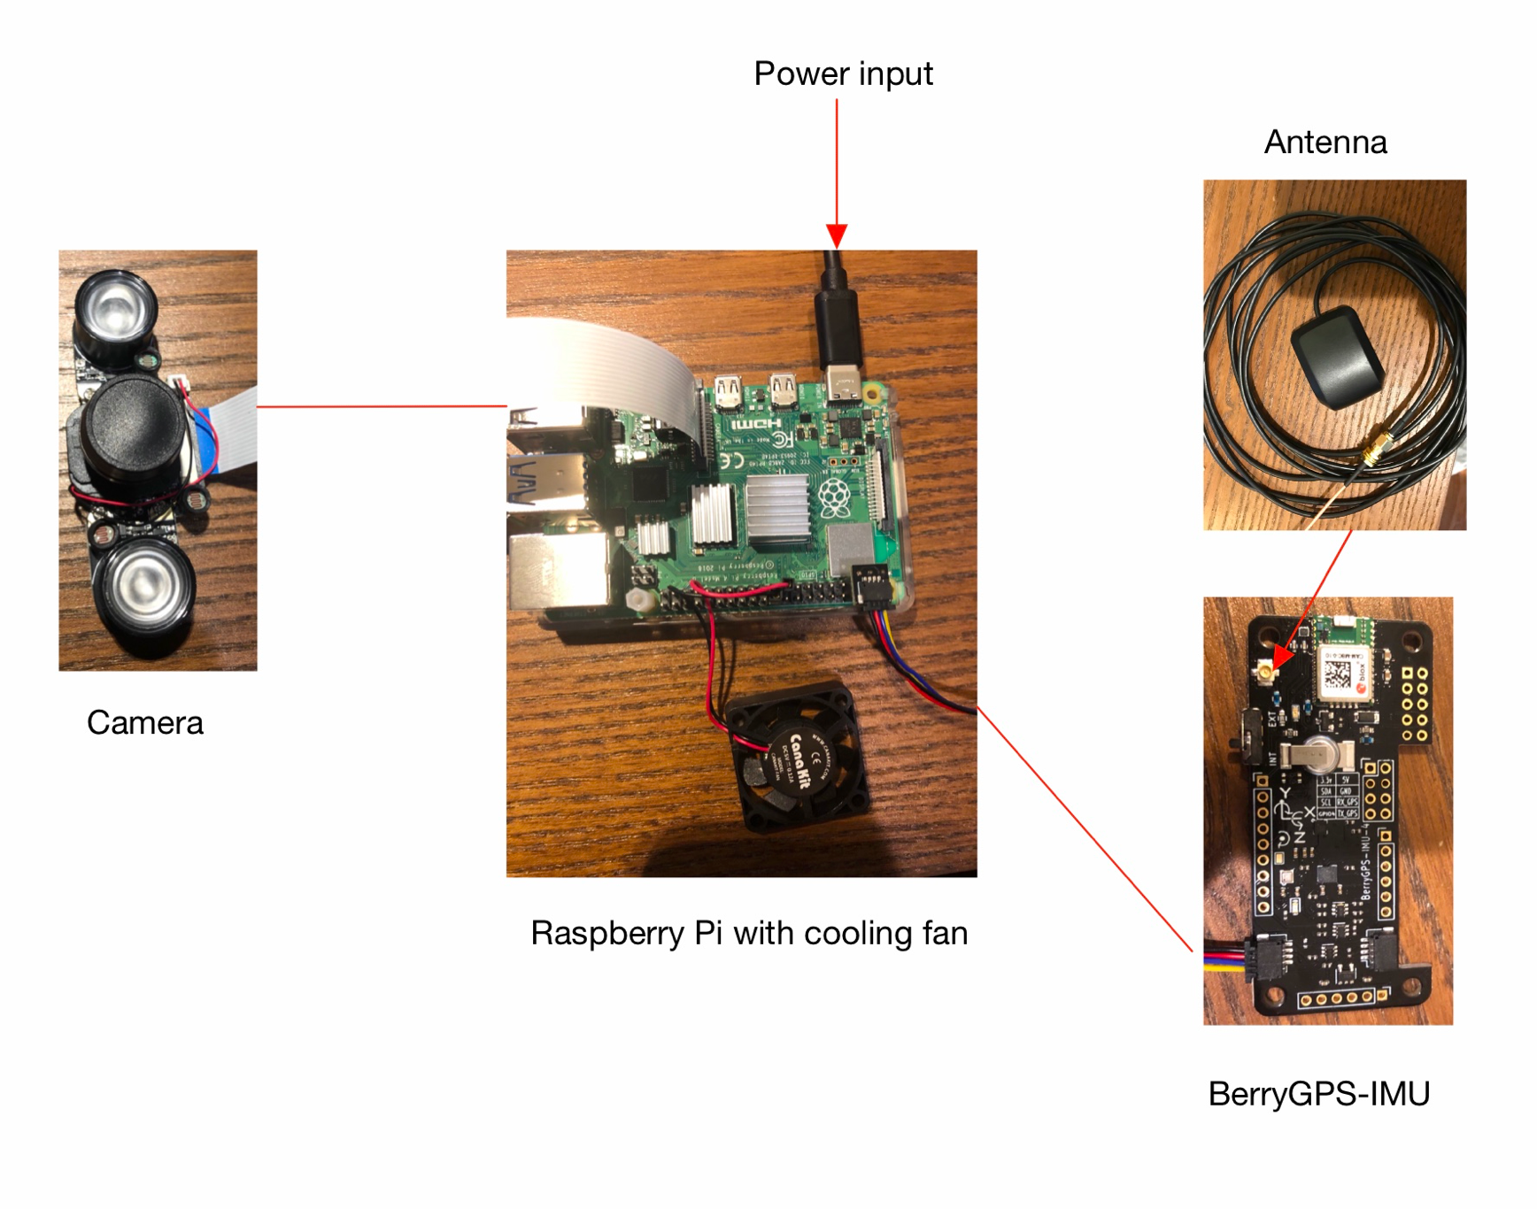

3.0 Test Procedure
Pre-testing Setup Procedure:
Raspberry Pi4:
1, Enable i2c interface
2, Enable Serial port interface
3, Disabled Serial console
4, Run IMU_interface.c
5, Run GPS.py
6, Run Test.py
1. Extract data from sensors
Hardware:
- Place the BerryGPS-IMU outdoor
- Get the result data which includes barometer, temperature, altitude, longitude, latitude, pitch, roll, yaw from output data file.
- Place the BerryGPS-IMU indoor
- Get the same result data again
- Compare the result data with the actual data which could be referenced on the Internet and make sure the system is working properly and precisely.

2. Calculate angle of airspeed needle

asdfasdf

3. View .fdr file on X-Plane

Column Header | Explanation | Example
time secon | time in seconds from the beginning of the recording | 1
temp deg C | temp in degrees celsius of the ambient air near the airplane at current altitude | 45
lon degre | longitude in degrees | –117.20
lat degre | latitude in degrees | 34
h msl ft | height above mean sea level in TRUE feet, regardless of any barometric pressure setting or other errors | 4010
radio altft | radio altimeter indication | 0
ailn ratio | aileron deflection in ratio –1.0 (left) to +1.0 (right) | 0
elev ratio | elevator deflection in ratio –1.- (nose down) to +1.0 (nose up) | 0
rudd ratio | rudder deflection in ratio –1.- (left) to +1.0 (right) | 0
ptch deg | pitch in degrees, positive indicating up | 0
roll deg | roll in degrees, positive indicating right | 0
hdng TRUE | heading in degrees TRUE | 0
speed KIAS | speed in knots | 250.1
VVI ft/mn | indicated vertical speed in feet per minute | 0.2
slip deg | indicated slip in degrees, positive indicating nose right | 0
turn deg | turn-slip indicator deflection, positive indicating right | 0.4
mach # | Indicated Mach number | 0.5
AOA deg | Indicated Angle of Attack | 1
stall warn | Stall warning on, 1 or 0 | 0
flap rqst | Flap handle position, 0.0 (retracted) to 1.0 (extended) | 0
flap actul | Flap–1 deflection ratio, 0.0 (retracted) to 1.0 (extended) | 0
slat ratio | Slat–1 deflection ratio, 0.0 (retracted) to 1.0 (extended) | 0
sbrk ratio | Speedbrake deflection ratio, 0.0 (retracted), (1.0 extended), 1.5 (ground-deployed) | 0
gear handl | Gear handle, 0 (up) to 1 (down) | 1
Ngear down | Gear #1 (nose?) deployment ratio, 0.0 (retracted) to 1.0 (down) | 1
Lgear down | Gear #2 (left?) deployment ratio, 0.0 (retracted) to 1.0 (down) | 1
Rgear down | Gear #3 (right?) deployment ratio, 0.0 (retracted) to 1.0 (down) | 1
elev trim | Elevator trim, –1.0 (nose down) to 1.0 (nose up) | 0
NAV–1 frq | Nav–1 frequency in a 5-digit integer form with no decimal | 11010
NAV–2 frq | Nav–2 frequency in a 5-digit integer form with no decimal | 10930
NAV–1 type | Nav–1 type (NONE=0, NDB=2, VOR=3, LOC=5, ILS=10) | 4
NAV–2 type | Nav–2 type (NONE=0, NDB=2, VOR=3, LOC=5, ILS=10) | 4
OBS–1 deg | OBS–1 in degrees 0 to 360 | 90
OBS–2 deg | OBS–2 in degrees 0 to 360 | 270
DME–1 nm | 0.0 means no DME found, any positive value means we are getting DME data | 0
DME–2 nm | 0.0 means no DME found, any positive value means we are getting DME data | 0
NAV–1 h-def | Horizontal (localizer) deflection, –2.5 to 2.5 dots, positive fly right | 2.5
NAV–2 h-def | Horizontal (localizer) deflection, –2.5 to 2.5 dots, positive fly right | 2.5
NAV–1 n/t/f | Nav–1 NAV/TO/FROM (nav=0, to=1, from=2) | 1
NAV–2 n/t/f | Nav–1 NAV/TO/FROM (nav=0, to=1, from=2) | 1
NAV–1 v-def | Vertical (glideslope) deflection, –2.5 to 2.5 dots, positive fly up | 2.5
NAV–2 v-def | Vertical (glideslope) deflection, –2.5 to 2.5 dots, positive fly up | 2.5
OM over | Over marker 0 or 1 | 0
MM over | Over marker 0 or 1 | 0
IM over | Over marker 0 or 1 | 0
f-dir 0/1 | Flight director on, 0 or 1 | 0
f-dir ptch | Flight director pitch in degrees, positive indicating up | 10
f-dir roll | Flight director roll in degrees, positive indicating right | 10
ktmac 0/1 | Autopilot is holding knots or mach number (knots=0, mach=1) | 0
throt mode | Auto-throttle mode (off=0, on=1) | 0
hdg mode | Autopilot heading mode (0=wing-level, 1=heading, 2=localizer or other CDI) | 0
alt mode | Autopilot altitude mode (3=pitch sync, 4=vvi, 5=airspeed, 6=airspeed with alt arm, 7=alt hold, 8=terrain-follow, 9=glideslope hold) | 0
hnav mode | Localizer CDI is ARMED for capture 0 or 1 | 0
glslp mode | Glideslope CDI is ARMED for capture 0 or 1 | 0
back mode | Back-course on 0 or 1 | 0
speed selec | Autopilot speed selection, knots or Mach number | 0
hdg selec | Autopilot heading selection, degrees magnetic | 0
vvi selec | Autopilot vertical speed selection, feet per minute | 0
alt selec | Autopilot altitude selection, feet MSL indicated | 500
baro in hg | Barometric pressure dialed into the altimeter, inches HG | 29.9
DH ft | Decision height dialed into the radio alt, feet AGL | 0
Mcaut 0/1 | Master Caution alerting 0 to 1 | 0
Mwarn 0/1 | Master Warning alerting 0 to 1 | 0
GPWS 0/1 | Ground Proximity Warning 0 to 1 | 0
Mmode 0–4 | Map mode: 0 through 4 can give different map results | 0
Mrang 0–6 | Map range: 0 through 6 will give different map ranges | 0
throt ratio | Throttle ratio 0.0 to 1.0 (emergency settings can actually exceed 1.0) | 1
prop cntrl | Propeller RPM command, per engine | 2005
prop rpm | Propeller RPM actual, per engine | 2005
prop deg | Propeller pitch in degrees, per engine | 30
N1 % | N1, per engine | 100.1
N2 % | N2, per engine | 100.1
MPR inch | Engine Manifold Pressure, per engine | 0
EPR ind | Engine Pressure Ratio, per engine | 0
torq ft*lb | Engine torque, per engine | 584.1
FF lb/hr | Fuel Flow, per engine | 400
ITT deg C | Turbine Inlet Temperature, per engine | 1000
EGT deg C | Exhaust Gas Temperature, per engine | 1000
CHT deg C | Cylinder Head Temperature, per engine | 0

4.0 Measurements and Criteria for Success

Test 1: The output data of roll, pitch, and yaw match the movement of the BerryGPS-IMU. The output data of GPS will show it is trying

Test 2:

Test 3: View .fdr file on X-Plane

Test Case | Runtime | Success Case
.FDR Sample 20 Seconds Linear Track | 20 s | Runs with a Steady speed (250 Knt)
.SIT/.REP Sample Alteration & Data Recording | 10 s | Writes Data.txt while running
.FDR Altered 20 seconds Linear Track | 20 s | Accelerates & Decelerates based on provided Data
.FDR Altered 1 minute Right Embankment | 20-60s | Runs, Turns in one direction based on applied coordinates

